File Organization
# Source: AI Source: Provided by: [Data Path: Persons Table -> ID Column: 1, Name_En Column: Motasem Essam] -> From: [Chatgpt (GPT‑5 Mini)] on [1/26/2026]
File Organization refers to the way data (records) are arranged and stored inside a file so that it can be accessed, processed, and updated efficiently.
In simple words: it’s how records are organized in a file.

Types of File Organization

1. Sequential File Organization
# Source: AI Source: Provided by: [Data Path: Persons Table -> ID Column: 1, Name_En Column: Motasem Essam] -> From: [Chatgpt (GPT‑5 Mini)] on [1/26/2026]
- Records are stored one after another in order.
- Usually based on a key field (like ID).
- Access is sequential (start from the beginning).
Example:
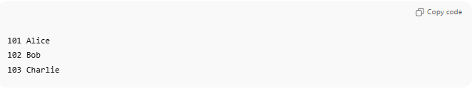
101 Alice
102 Bob
103 Charlie
Used when:
✔ Data is processed in order
❌ Slow searching

2. Random (Direct) File Organization
# Source: AI Source: Provided by: [Data Path: Persons Table -> ID Column: 1, Name_En Column: Motasem Essam] -> From: [Chatgpt (GPT‑5 Mini)] on [1/26/2026]
- Records can be accessed directly using a key or address.
- No need to read previous records.
Example:
- Want record 102 → jump directly to it.
Used when:
✔ Fast access needed
✔ Frequent updates

3. Indexed File Organization
# Source: AI Source: Provided by: [Data Path: Persons Table -> ID Column: 1, Name_En Column: Motasem Essam] -> From: [Chatgpt (GPT‑5 Mini)] on [1/26/2026]
- Uses an index (like a book index).
- Index points to the location of records.
Example:
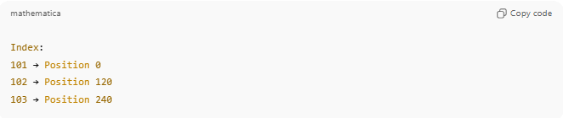
Index:
101 → Position 0
102 → Position 120
103 → Position 240
Used when:
✔ Fast searching
✔ Large files

4. Indexed Sequential File Organization
# Source: AI Source: Provided by: [Data Path: Persons Table -> ID Column: 1, Name_En Column: Motasem Essam] -> From: [Chatgpt (GPT‑5 Mini)] on [1/26/2026]
- Combination of sequential + indexed.
- Records stored sequentially, index allows fast access.
Used when:
✔ Both sequential processing and fast searching are needed

5. Hashed (Direct) File Organization
# Source: AI Source: Provided by: [Data Path: Persons Table -> ID Column: 1, Name_En Column: Motasem Essam] -> From: [Chatgpt (GPT‑5 Mini)] on [1/26/2026]
• Uses a hash function to calculate the address of a record.
• Records are stored based on the hash value of the key.
• Allows very fast direct access.
Example:
• Hash function: h(key) = key mod 10
• Key = 102 → 102 mod 10 = 2 → store at location 2
Used when:
✔ Very fast record retrieval required
✔ Exact match searching (not range searching)

Why File Organization Is Important
# Source: AI Source: Provided by: [Data Path: Persons Table -> ID Column: 1, Name_En Column: Motasem Essam] -> From: [Chatgpt (GPT‑5 Mini)] on [1/26/2026]
- Improves speed of access
- Saves storage space
- Makes updating and searching efficient
- Improves overall system performance

Quick Summary Table
# Source: AI Source: Provided by: [Data Path: Persons Table -> ID Column: 1, Name_En Column: Motasem Essam] -> From: [Chatgpt (GPT‑5 Mini)] on [1/26/2026]
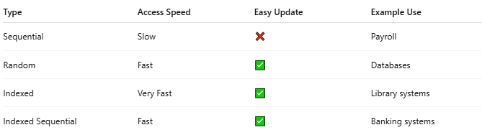
Type | Access Speed | Easy Update | Example Use
Sequential | Slow | ❌ | Payroll
Random | Fast | ✅ | Databases
Indexed | Very Fast | ✅ | Library systems
Indexed Sequential | Fast | ✅ | Banking systems

💡 Analogy:
# Source: AI Source: Provided by: [Data Path: Persons Table -> ID Column: 1, Name_En Column: Motasem Essam] -> From: [Chatgpt (GPT‑5 Mini)] on [1/26/2026]
- File Organization is like arranging books in a library:
  - Sequential → stacked in order
  - Indexed → index + shelf number

